Dear Hillcrest Neighbor,

Please join us in helping beautify our Neighborhood. WE ARE NOT AN HOA (Home Owners Association) or PID (Public Improvement District) but a "VOLUNTARY Informal" which means NO DUES, NO FEES, NO REGULATIONS!

If you haven't noticed our Entry Feature as you've entered into the subdivision let me share with you what has happened in the past few months after the Survey's went out.
Phase I - cleared flower boxes of old vegetation
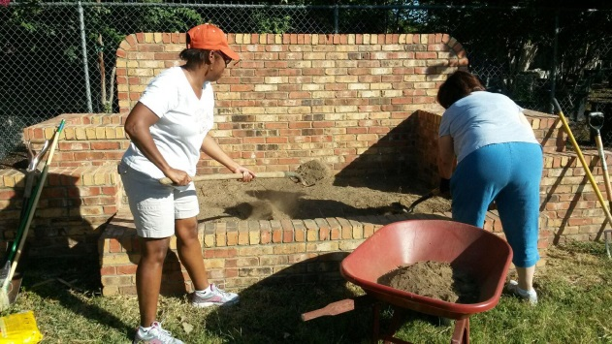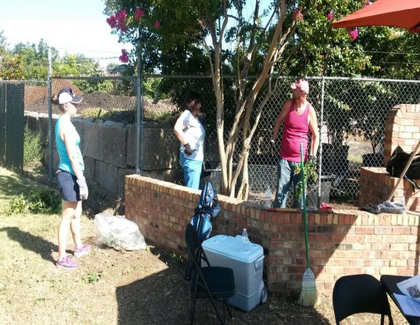.
Phase II – Added new soil, and new plants along with added some solar lighting and what you see today are these completed projects.

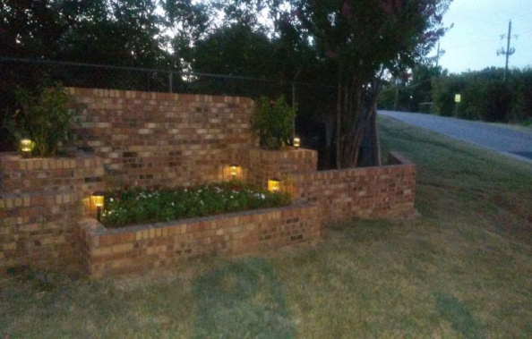
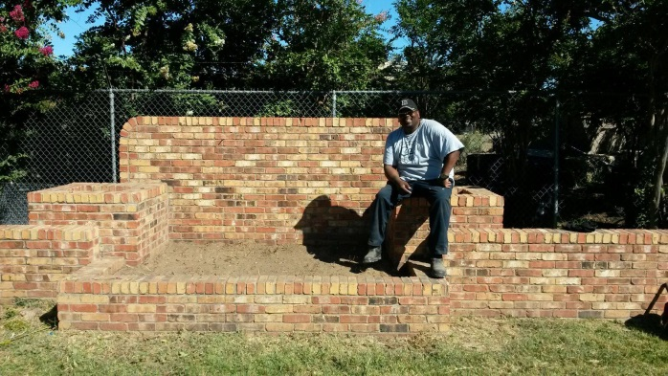

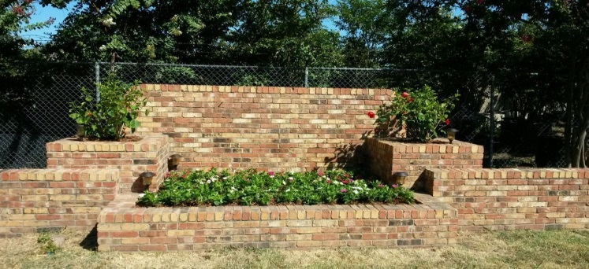
Phase III - We need monetary donations to get our Letters "HILLCREST" put on the brick flower box. We have gotten an estimate for $2,000.00 and have raised $240.00 dollars toward this goal. Please contact Faye Burton fayeburton450@yahoo.com to donate today!

